**Blog Development**

**Featrures:**

i)Login control

ii)Posting capability

iii)Seeing each other post

iv) Edit/Delete your own post

**Steps:**

i)When you goto **localhost:8080** this page opens

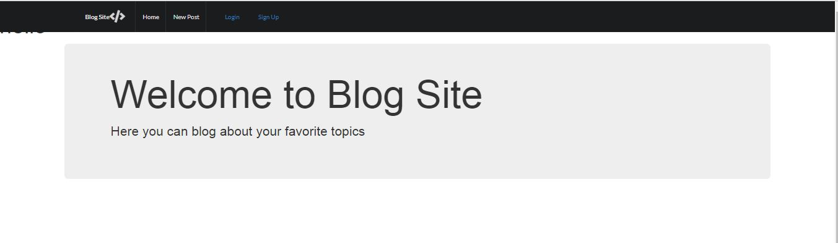

You have two options now either to signup or login

ii)Signup- If you click on sign up this page opens

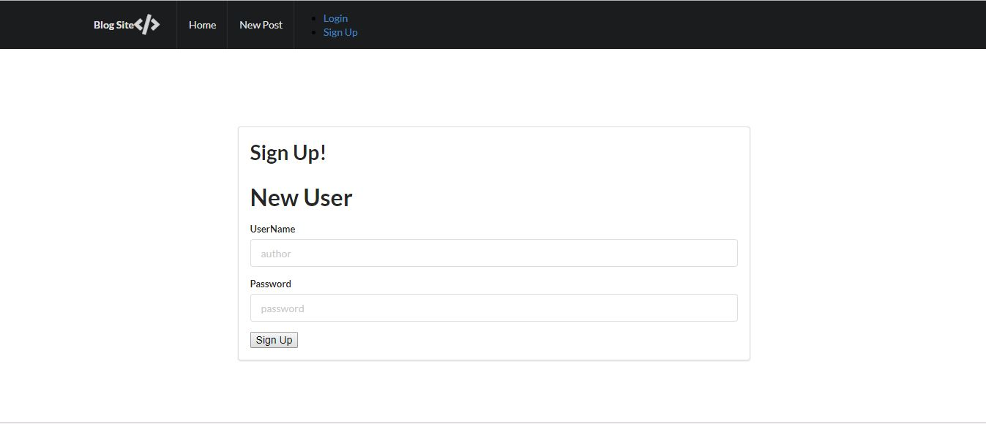

iii)After successful signup you will be directed to login page where u can login using Username and password. After login u will be taken to home page. 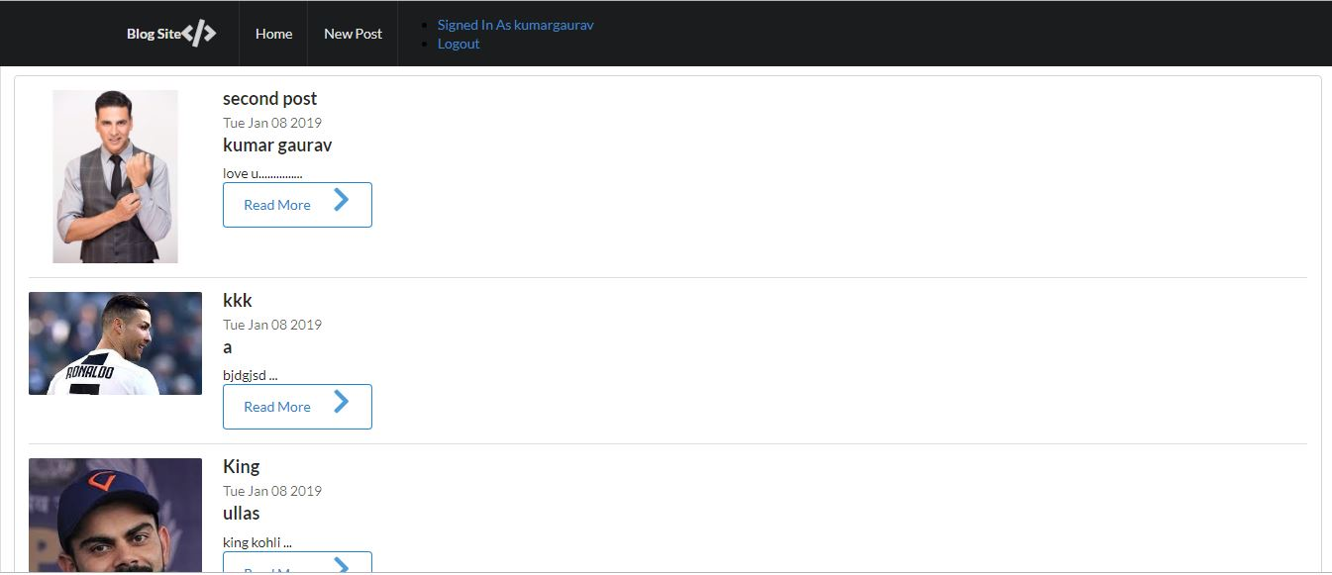

iv)When u want to do new post click on new post button

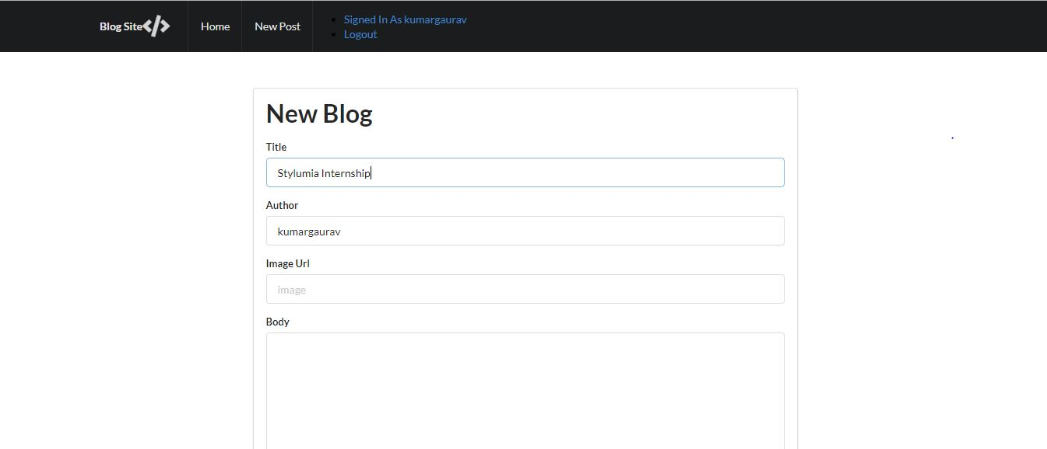

v)After that you have one more feature of edit and delete your own post.

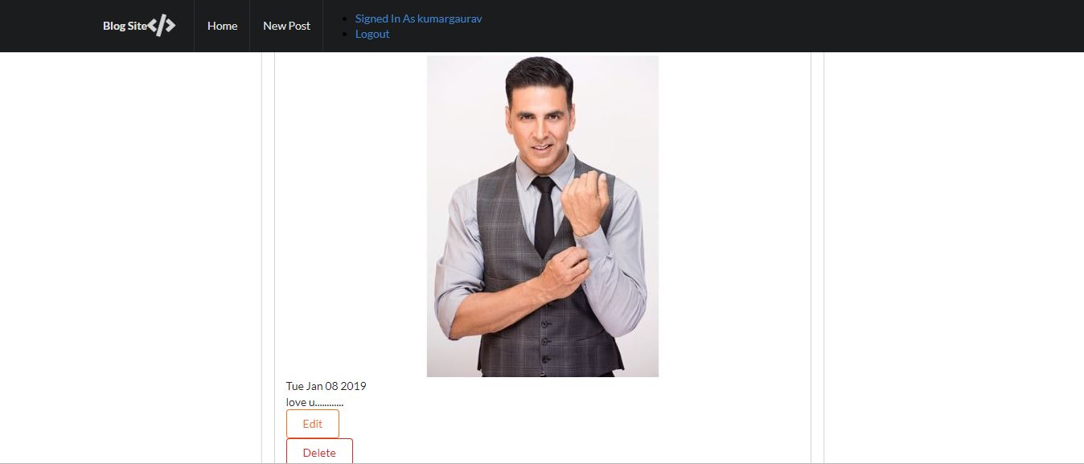

vi)At last u can logout.